Lesson 3.5: Updating our Models

Location: Classroom  Grade Level: High School  Time: One class session of 50 minutes  Driving Question  - How can we update our models to show the effects of climate change on the ocean and the values our communities hold for it? | Lesson Synopsis  In this lesson, students revisit their models from Module 2 that share how their communities value the ocean. Students use the evidence they gathered from their investigations to expand and refine the processes in their model, such as sea level rise, coastal erosion, ocean acidification, or global warming, and how human impacts drive these processes to change over time.  After the models have been refined, students begin to prepare for Module 4 by planning what they want to communicate to their community as a potential solution or action they can take to mitigate the effects of climate change on the values they place on Southern California’s ocean.  What students will figure out:  - Human-driven increases in carbon dioxide influence multiple interconnected processes, such as global warming, sea level rise, coastal erosion, and ocean acidification.  - Refining system models helps students represent how these processes interact and change over time.

LEARNING OUTCOMES

By the end of this investigation, students will be able to… | You can assess this using…
- Refine their Module 2 model to expand the human influence on natural processes, such as sea level rise, coastal erosion, ocean acidification, or global warming. | Student group Module 2 models in the Investigate, Putting Pieces Together sections.
- Explain how human activities impact natural processes in their model and relay their potential impact on the ocean and their communities. | Class discussion in the Navigate section.
- Reflect on what information they want to communicate out to their community to address climate-related impacts on the values they hold for Southern California’s ocean | Reflection in the Navigate section.

Building towards NGSS and AI Literacy:
- HS-ESS3-6: Use a computational representation to illustrate the relationships among Earth systems and how those relationships are being modified due to human activity. In this lesson, students will construct a model based on local climate change and how human activity contributes to positive and negative effects in the environment.

Lesson Overview

Section | Time | What Happens
Investigate | 15 minutes | Students revisit their Module 2 models that show how their communities value the ocean. They plan with their groups how they will use their newfound knowledge to update their model to expand ideas connected to natural processes, such as sea level rise, coastal erosion, or ocean acidification.
Putting Pieces Together | 25 minutes | After coming up with a plan, student groups expand their models to incorporate their findings, focusing on adding details that connect climate-related changes to human activities and their impacts on the ocean.
Navigate | 10 minutes | As a class, students share their group models, highlighting their chosen value, the processes they updated in their model, and how they updated these processes.
Navigate | 5 minutes | Students begin chatting about what information they want to communicate back out to their community.

MATERIALS
- Lesson 3.5 Slideshow
- Science Journal
- SageModeler Examples (also see p. 3)
- SageModeler models that students created (from Module 2)

BEFORE YOU START TEACHING
- Include a numbered list of general steps to set up the investigation before students arrive.

SageModeler Examples
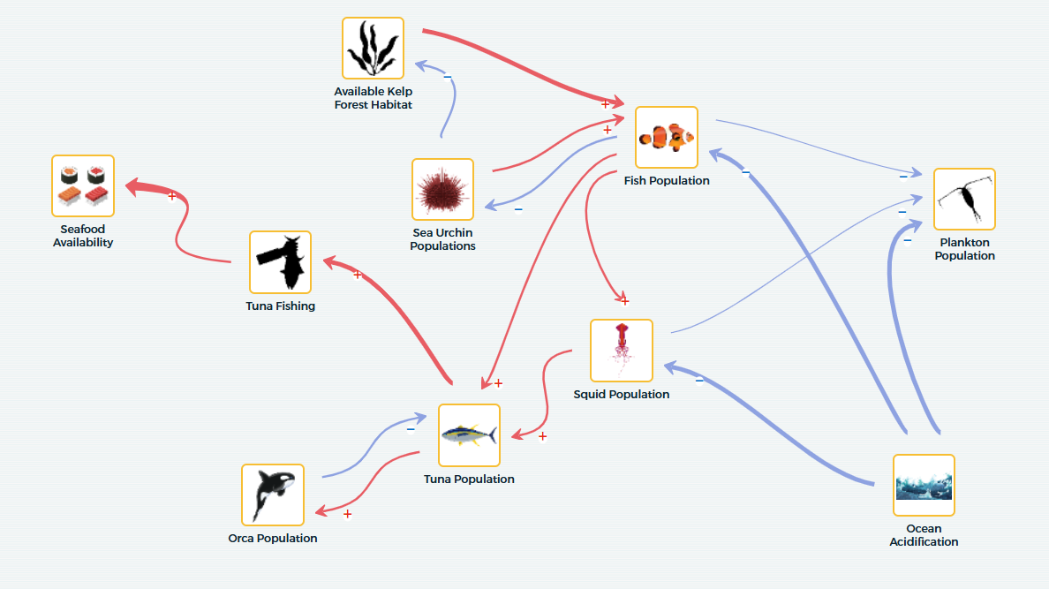
Seafood Model 1 (No CO2)

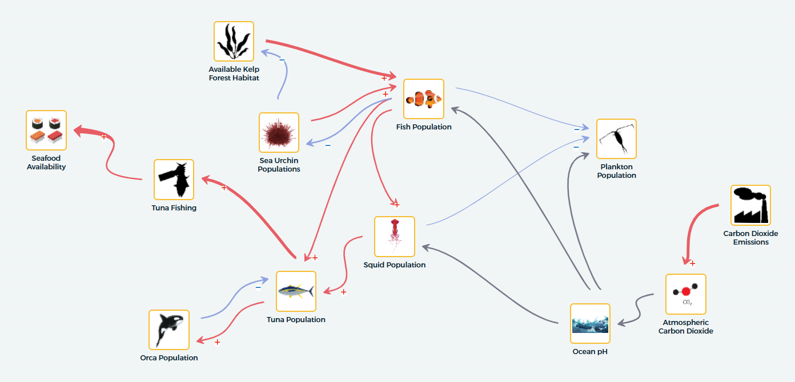
Seafood Model 2 (Adding CO2)

WHERE WE ARE GOING AND NOT GOING
Where We Are Going: In this lesson, students are building on their prior models to synthesize knowledge from multiple investigations, including ocean acidification, sea level rise, and coastal erosion. The focus is on refining their understanding of how human activities drive changes in ocean systems and visualizing these processes in a coherent model. Students will also begin thinking about solutions and community action, specifically which aspects of their models they might want to communicate to a larger audience.

Where We Are NOT Going: This lesson does not cover detailed policy planning, engineering solutions, or quantitative modeling of climate impacts. While students will prepare for Module 4 by starting to think about potential solutions or community actions, they do not yet delve into the science communication aspect of these solutions.

LEARNING SEQUENCE
Lesson plan notes are also provided on the slide notes.

INVESTIGATE: Revisiting our Models (15 minutes)

- Open the slideshow to Slide 1 and invite the class to get together for the final lesson of Module 3.

- Advance to Slide 2 to show the Overview of lesson 3.5. Explain to students that in this lesson, they will bring all the new findings from Module 3 to update our models about how climate change impacts the values their community places on the ocean.

- When you are ready, begin by inviting students to get into their model groups from Module 2 and have students bring up the models on SageModeler from Module 2.

- Advance to Slide 3, and have students open their Science Journals to Module 3.5: Updating our Models (Student Task: Plan SageModeler Update), p. 56-57. Here, groups will plan how they will use their new knowledge to update their models.
- Which processes that we have studied, including sea level rise, coastal erosion, global warming, and ocean acidification, affect the values your community cares about? How do they affect the components you have in your models?
  - Which processes do you want to add to your model?
- Which components were not in your original model that you want to add now?
- Which relationships were not in your original model that you want to add now?
- What human activities contribute to the changes in these natural processes?

- As students are working in their groups, walk around and help support them by asking probing and pressing questions.
  - Is there a component that may be missing here? Think back to the beginning of Module 3.
  - How do you think this component connects to what you learned in Module 3?
  - How might we make this relationship explicit in our model?
- As students finish working in their Science Journals, take a moment to gather the class back together and let them know that their next step is going to be including these changes into their SageModeler models.

PUTTING PIECES TOGETHER: Updating our Models (25 minutes)

- Have groups rejoin their team and advance to Slide 4. Explain to students that they will now begin revising their SageModeler models using the plans they created in their Science Journals.

As you revise your models, keep the following in mind:
- How does carbon dioxide play a role in your model?
- How does carbon dioxide impact other processes in your model?
- How can you demonstrate carbon dioxide’s relationship to other portions of your model?

- Give students 15 minutes to work on updating their models.

As students are working, make sure to walk around and provide support to help them refine their models. Emphasize to students how to demonstrate direct relationships and indirect relationships. Make sure that students include carbon dioxide as a component in their model.
- Does this component play a larger role in impacting your community value than previously thought? How can you change the intensity of the relationship to reflect this (e.g., by increasing the relationship magnitude within SageModeler)?
- Can you explain how this human-caused impact indirectly impacts the value your community places on Southern California’s ocean?

- At the 15-minute mark, call student groups back to the class and advance to Slide 5. Ask students:
  - What changes did you make to your model?

- Tell students that now that they have made revisions, together, they will track how one component that they explored in the last module, carbon dioxide emissions, impacts the value their model is centered around. If they haven’t added carbon dioxide emissions in yet, give them a moment to include it.

- Advance to Slide 6 and have students open their Science Journals to Module 3.5: Updating Our Models (Student Task: Make a Prediction), p.58. Here, students will be asked to make a prediction on how their chosen value will change as carbon dioxide emissions increase.
Prediction Sentence Frame
We predict that as carbon dioxide emissions increase, [our value] will [describe the change]. This is because [explain the process using the model as evidence].

Examples:
- We predict that as carbon dioxide emissions increase, our seafood availability will decrease. This is because higher carbon dioxide levels decrease the ocean’s pH, which reduces the survival of calcifying organisms that fish depend on for food.
- We predict that as we increase carbon dioxide emissions, our access to the coast will decrease. This is because high carbon dioxide levels increase the global temperature, melting ice caps and raising sea levels, leading to more coastal flooding and erosion.

- Advance to Slide 7 and tell students that now it is time to test their prediction. Tell students that to test their prediction, they will run simulations in SageModeler. At the top right of your SageModeler screen, click on “Simulate”, and bars will appear on components within your model.

- Have students move their carbon dioxide emissions bar to the bottom (lowest levels of carbon dioxide emissions) and then test their prediction by slowly moving the bar up towards higher levels of carbon dioxide emissions. As students do that, have them think about the following questions:
  - What is happening to my chosen value as carbon dioxide emissions increase?
  - What is happening to other components or processes within my model as carbon dioxide levels increase?

Note: If students have added components that contribute to carbon dioxide emissions, they may have to manipulate those instead of carbon dioxide emissions directly.

- If there is time, ask students to test other components within their model following the same process.

NAVIGATE: Sharing our Models (10 minutes)
- Once student groups have had a chance to test their models out, bring the class back together to share what they found. Advance to Slide 8 and ask the class the following questions:
  - What value did your team center their model around? How did an increase in carbon dioxide emissions impact your chosen value?
  - What processes or components do you think had the biggest impact on your value?
  - What discoveries about your model and its relationships were the most surprising to your team? Why?

Listen for and reinforce ideas that connect carbon dioxide emissions to impacts of other portions within their models, leading to a change in the value their community places on Southern California’s ocean.

- Once students have shared their findings, advance to Slide 9, where they will see another question to discuss with the class
  - What is something about your model that you think everyone should know?
  - If you had to explain your updated model to someone in the community, what would you highlight first?

NAVIGATE: Looking Ahead - What Do We Want to Share with Our Community? (5 minutes)
- As students wrap up for the day, their final task for the day is to reflect on what they did.

- Advance to Slide 10 and have student teams work together to answer the following questions together on Module 3.5 Updating our Models (Student Reflection) page 59 of their Science Journals.
  - If you were explaining your updated model to someone in your community, what key idea or relationship would you highlight? Why should this idea or relationship matter to them?
  - Based on what your model now shows, what action or solution could your community take to reduce or respond to these impacts?

- Thank students for their participation today and inform them that in the next session, they will start to think about what information they want to communicate back out to their community and how they might do so.

